

SRINIVASA RAMANUJAN INSTITUTE OF TECHNOLOGY

(AUTONOMOUS)

(Affiliated to JNTUA, Accredited by NAAC with ‘A’ Grade, Approved by AICTE, New Delhi & Accredited by NBA (EEE, ECE & CSE)

Rotarypuram Village, BK Samudram Mandal, Ananthapuramu-515701

Department Of Computer Science & Engineering (AI& ML)

**REAL TIME VEHICLE TRACKING & DYNAMIC SIGNAL CONTROL**

**THROUGH SURVEILLANCE CAMERAS**

Academic Year : 2023-2024 Year & Sem : IV-II



ABSTRACT

**BATCH NO : A – 08**

**Under the guidance of**

**Mr. A. Kiran Kumar**



**TING THE OBJECTS I**

**B. Laya Sree 204G1A3224**

**G.Harish Kumar 204G1A3212**

**B.Sunil 204G1A3256**

**K.Asha 204G1A3202**





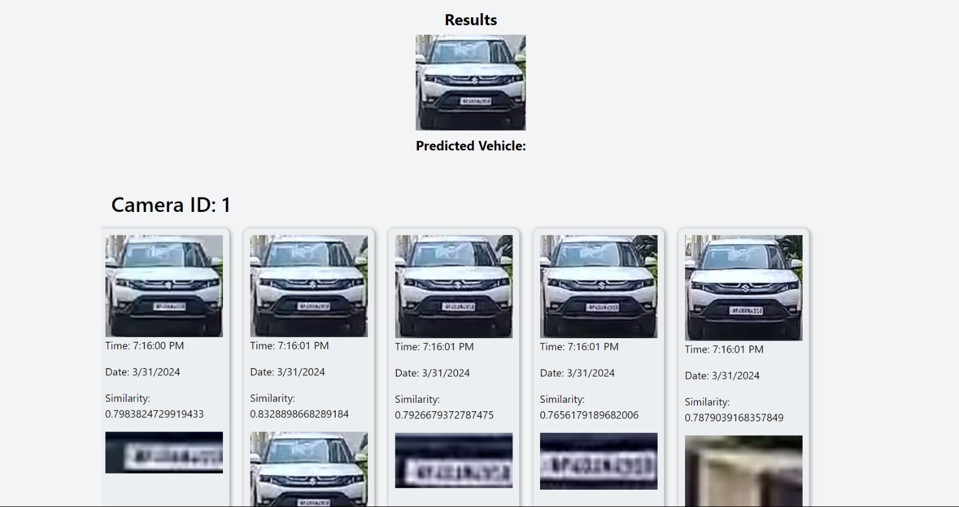

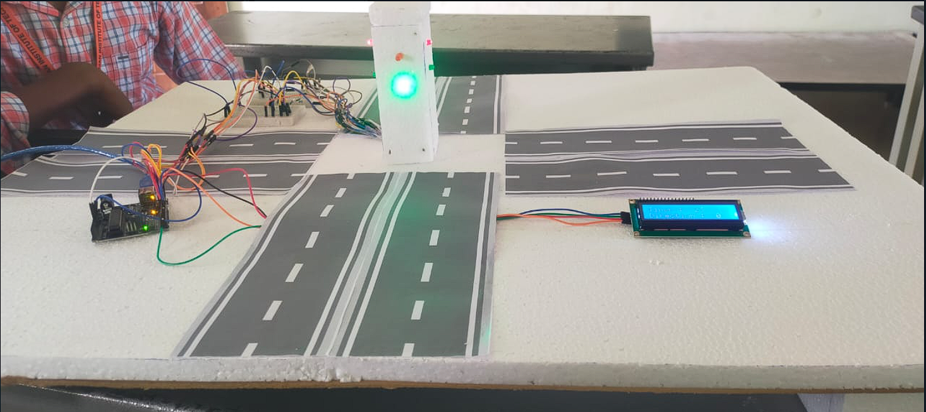

1. Improved Traffic Monitoring: Provides a comprehensive view of traffic flow across camera networks.

2. Reduced Traffic Congestion: By dynamically adjusting green light times based on real-time traffic flow, this system could potentially improve traffic flow and reduce congestion.



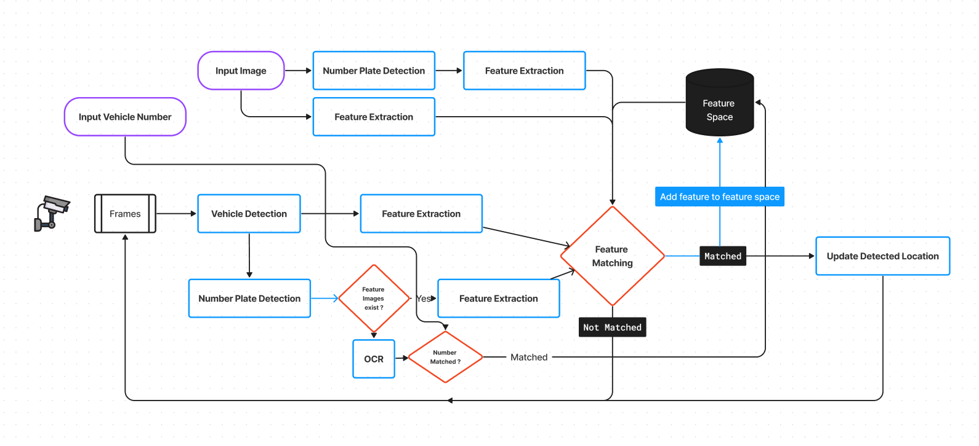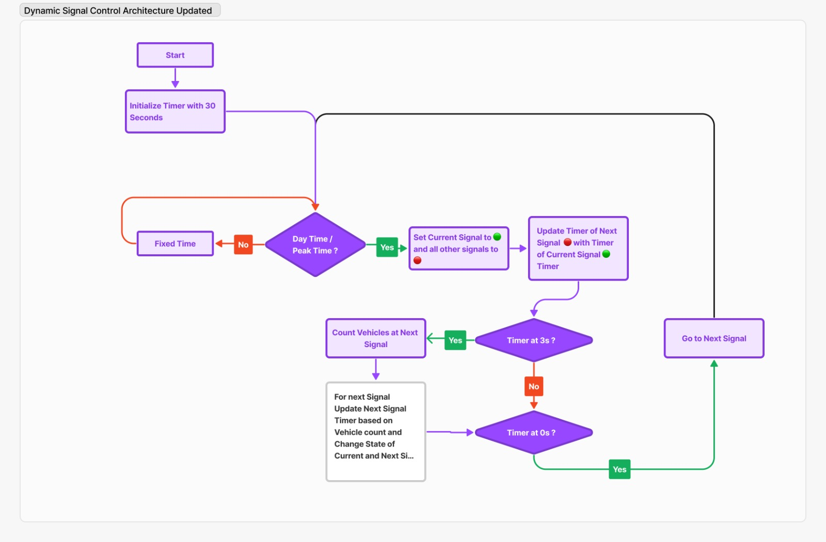



1. Data Acquisition
2. Preprocessing
3. Object Detection and Tracking Module
4. Signal Control Module

This paper presents a Real-time Vehicle Tracking and Dynamic Signal Control (RT-VTR-DSC) system utilizing surveillance cameras to optimize urban traffic flow. The RT-VTR module employs advanced computer vision techniques, including deep learning algorithms, for real-time vehicle monitoring and tracing across road networks, offering crucial data for traffic management. Complemented by the Dynamic Signal Control (DSC) component, the system adjusts signal timer dynamically based on live camera data to minimize average waiting time, reduce congestion, and enhance traffic efficiency.

This describes two methodologies for using surveillance cameras. The first outlines a system for real-time vehicle tracking that captures video from strategically placed cameras, preprocesses the video data, and uses object detection algorithms to identify and track vehicles across different camera views. The second methodology describes a system for dynamic traffic signal control that uses sensors to monitor real-time vehicle counts and allocates green light time based on the direction with the highest traffic density. Both methodologies are evaluated through a combination of simulation and real-world testing to measure their effectiveness.

ADVANTAGES OF PROPOSED SYSTEM

SYSTEM

CONCLUSION

In the contemporary landscape, DDoS attacks pose significant threats. To mitigate the associated losses by promptly identifying targeted networks, we have developed a model leveraging the LSTM algorithm. This model exhibits a remarkable accuracy of 93%, surpassing established machine learning counterparts such as Decision Tree and Gradient Boosting algorithms. Implemented in Python, our solution not only enhances detection capabilities but also operates seamlessly in real-time network environments, providing a superior and intuitive solution. To ascertain whether or not the network is under assault, the system probably collects user data. For Future work, this model can be enhanced to cloud environment as the cloud is the most targeted place by the DDoS attackers which may affect the organizations.

* **Captures video streams from strategically positioned surveillance cameras.**
* **Normalizes, resizes, and potentially augments video frames for consistency and quality improvement.**
* **Implements YOLO trained on vehicle and license plate datasets to identify and track vehicles across camera views.**
* **Dynamically allocates green light time based on analysis from previous module.**

PROPOSED SYSTEM

**BATCH NO : B - 14**

**Under the guidance of**

Mrs. S. Sunitha, M.Tech. Ph.D.



**TING THE OBJECTS I**

**Ravi Babu V C 204G1A3308**

**Upendra P 204G1A3359**

**Baba Hussain S 204G1A3305**

**Pavani B 204G1A3331**